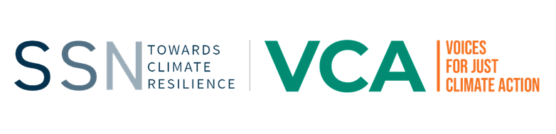
Voice for Climate Action (VCA) Proposal, Zambia – SouthSouthNorth Communications Partner
The Voices for Climate Action (VCA) programme is a lobby and advocacy programme being implemented by the World Wide Fund for Nature (WWF) Netherlands, SouthSouthNorth (SSN), Akina Mama wa Afrika (AMwA), Slum Dwellers International (SDI), Fundación Avina and Hivos under the Dutch Ministry of Foreign Affairs’ five-year strategic partnership: “Power of Voices”.
SSN, the knowledge partner for the VCA programme, has launched this call for proposals to support the knowledge management, brokering, communications and capacity development of the VCA Zambia programme and its local partners, in collaboration with other media partners working within VCA Zambia. This communications partner will be expected to oversee the development and overall effective implementation of the VCA Zambia communications strategy, as well as work closely under the supervision of SSN and coordinate with other sub granted media partners. This partner would be willing and able to work across up to 10 Districts in Zambia, namely: Luangwa, Rufunsa, Chongwe, Lusaka, Kafue, Chirundu, Siavonga, Chikankata, Mazabuka and Itezhi Tezhi.
Application deadline is Tuesday 22 February, 17h00 CAT
To apply, kindly complete the (1) proposal template and (2) budget template and send documents to infovca@southsouthnorth.org

For further information, questions or clarifications, please contact charlotte.scott@southsouthnorth.org
Successful applicants will be contacted to discuss their proposal for how they plan to fulfil the communications partner objectives within the programme.
Lead applicant details
Name of lead applicant and email address
Name of organisation

(Registered legal entity name ) Registration status
Postal address
Physical address

Organisation website
Name, email address and phone number of contact person if not the lead applicant

Overview
Funding requested from SSN
Organisation overview

(Maximum 350 words)
Summary of proposal

(Maximum 300 words)

Proposal Objectives (1 page)

Overall Objectives

Expected Results

Approach, Strategy and Methodology (1-2 pages)

Approach and Strategy
- Describe shortly your strategy and methodology
- Describe what are the best practices in this field if applicable,
- It is encouraged to illustrate by previous experiences where possible.

Implementing Partners (1/2 page)

- Describe who will implement the project; what role each partner has?
- Describe why these partners form current partnership (relevance) and how do the partners complement each other.
- Describe the project team, the complementarity of team members and the gender expertise available.
- Per team member describe their
  - professional and personal qualities
  - experiences with proposed approach and strategy
  - their particular role and added value in the project team
- CVs (add in Annex).

Workplan and Time Schedule
- Describe timebound activity plan.

Budget

Please see the attached budget template

