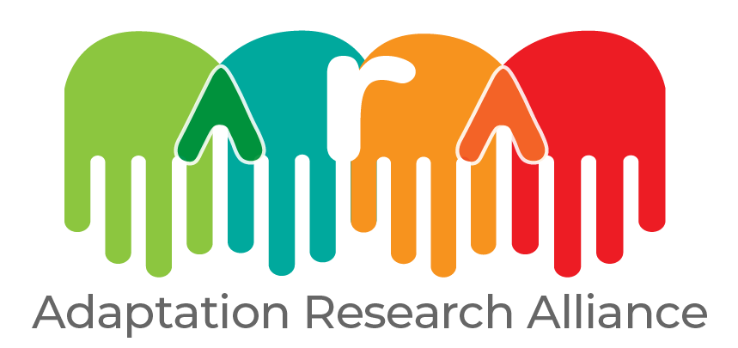

Application form
ARA micro-grants

Date: October 2022

Thank you for applying to the Grassroots Action Research micro-grants. Please read through the entire proposal note carefully before completing the sections. We look forward to reading through your proposal.

It is important that you fill out each section of the application, as well as stick to the stipulated word counts, or your proposal may not be considered for review. Once you have completed the proposal, please save the document as: Name of the language it is in, Organisation name, followed by ARA Micro-grants e.g. ‘’ENGLISH:ORGANISATION NAME:ARA MICRO-GRANTS' and email to
micro-grants@adaptationresearchalliance.org in either PDF or WORD format. Any other application documents, including in other formats (including screen shots) will not be accepted.
Should your proposal be eligible, it will be reviewed by external reviewers who will decide on the selection of successful grantees.
The eligibility check box below is for your own use, to ensure that your proposal meets the eligibility requirements. If you answer no to any of these questions, your proposal will not be considered for review. Please complete the box below, by deleting the relevant ‘yes’ or ‘no’ before emailing us your application, so that we know you have considered each question.
- Eligibility
Is the proposal lead organisation based in the country/region (in the Global South) facing the burning issue? | Yes/no
Do proposals involve at least one research and one action/grassroots entity? | Yes/no
Is the research institution based in the country of individuals who are affected by the issue at hand? (e.g. research end-user) | Yes/no
Is the burning issue to be explored driven by the needs of action stakeholders? | Yes/no
Have you explained how the Adaptation Research for Impact Principles will be incorporated into your approach? | Yes/no
Will at least 1 person in your proposal be able to participate in the meet and greet in May? | Yes/no
Will at least 1 person in your proposal be able to participate in the reflective workshops in September 2023 and January 2024? | Yes/no
Is the proposal lead, or relevant senior individual able to engage in requested MEL engagements (in the form of interviews, surveys, focus groups as needed)? | Yes/no
Is the budget within the proposal to the value of 15,000.00 GBP or under? | Yes/no
Have you ensured that your application complies with the micro-grant expenses protocol?
Has the NPAC (admin fee) of the proposal been inserted as no more than 10% of the total grant value? | Yes/no
Have you ensured that no alcohol, tobacco, or first class/premium travel is included as part of the budget? | Yes/no
Is your organisation able to receive money transfers from foreign accounts? | Yes/no
Is your proposal written in English, French or Spanish? | Yes/no
Have you explained how gender and social inclusion will be taken into account in the project proposal? | Yes/no
Are rates for staff included in the proposal competitive as per country/region? | Yes/no

2. Lead applicant details
Name of proposal lead and email address | Please state the name and email address of the individual leading the proposal
Name of organisation
(Registered legal entity name)
Global South or Global North | Please state if the Lead (organisation) is based in the Global South or Global North.
Type of organisation | Please delete as appropriate: Research Institution/Grassroots-Action Organisation/Intermediary/Government Institution
Please describe the type of work that your organisation/institution carries out | Please describe the type of work your organisation/institution carries out, specifically in relation to the work it will be doing for the micro-grants.
Postal address
Postal code
City
Country
Registered address
(If different from postal address)
Phone number
(Including country code)
Organisation website
Name and email address of contact person if not the lead applicant
2. Partner details (please include details of all the additional partners. Copy and paste the table if necessary)
Name of partner and email address
Proposed role in group
Name of organisation
Global South or Global North | Please state if the partner organisation is based in the Global South or the Global North.
Type of organisation | Research Institution/Grassroots-Action Organisation/Intermediary/Government Institution
Please describe the type of work that your organisation/institution carries out | Please describe the type of work your organisation/institution carries out, specifically in relation to the work it will be doing for the micro-grants.
Relationship with lead organisation | Please describe the nature of your relationship with the lead organisation, including for how long it has been in place
Postal address
Postal code
City
Country
Phone number
(Including country code)
Organisation website
2. Partner details (please include details of all the additional partners. Copy and paste the table if necessary)
Name of partner and email address
Proposed role in group
Name of organisation
Type of organisation | Please delete as appropriate: Research Institution/Grassroots-Action Organisation/Intermediary/Government Institution
Please describe the type of work that your organisation/institution carries out | Please describe the type of work your organisation/institution carries out, specifically in relation to the work it will be doing for the micro-grants
Relationship with lead organisation | Please describe the nature of your relationship with the lead organisation, including for how long it has been in place
Postal address
Postal code
City
Country
Global South or Global North | Please state if the partner organisation is based in the Global South or the Global North.
Phone number
(Including country code)
Organisation website

3. Issue to be addressed
Title
(Maximum 15 words)
Funding requested from ARA (maximum 15,000 GBP, including NPAC) | In Great British Pounds
Potential counterpart funding | State any potential for counterpart funding sources and amounts, and whether funds are secured or tentative, in cash or in kind
Summary of issue to be explored  (Maximum 150 words) | Include clear objectives.
Proposed activities for exploring the burning issue
(maximum 200 words)
Which of the Adaptation Research for Impact Principles will be utilised and how? (maximum 200 words)
Describe the role and value of both action and research in investigating the burning issue? (Maximum 150 words)
How does the issue to be explored respond to demand and/or needs of relevant national local actors, including government?  (maximum 150 words) | Please indicate how the issue to be explored responds to expressed demands and/or specific needs of stakeholders. Include references to relevant documents or reports, if necessary.
Key national and local actors to be engaged with in the exploration process, and description of current relationship  (Maximum 100 words) | Please identify your main actors to be engaged in the country, and whether a new relationship would be built. If the relationship is pre-existing, please identify the nature of the relationship(s), and for how long it has lasted.
Continuation of the grant (Maximum 150 words) | Please describe, if any, the vision for continuing micro-grant activities after the close of the grant.
Thematic focus  (Maximum 100 words) | Please indicate which adaptation themes this burning issue relates to (e.g. water resources, food/agriculture, health, cross-cutting).
Gender and equity considerations  (Maximum 200 words) | Please describe gender and social inclusion considerations and how they will be taken into account in this project. For example, how will you take into account the religion/gender/age/ability/caste etc. (as appropriate) of participants/project team members, and ensure their needs are met and views included.
Gender and equity considerations  (Maximum 200 words) | Please outline the gender(s) of the project team and their roles.
High-level indicative budget  (In Great British Pounds) | Please provide a high-level breakdown of the costs associated with the grant (day rates, itemised expenses etc).

4. Budget template
Description of activity/expense | Rate | Number/Unit | Total | Notes
E.g. workshop | 100 GBP | 1 | 100 | Workshop to convene community members and Government stakeholders in local Government Hall
Notes: Please provide day rates and the number of days per named partner. Please include estimated expenses (e.g. catering for a meeting) in an itemised description (e.g. 5 GBP/ per lunch x 30 people)
- Alcohol and tobacco are not allowed
- No first-class travel or economy premium allowed.
- The amount of NPAC calculated at the outset of the project is based on the agreed budget. The NPAC rate will be applied to the actual expenses incurred when claims are submitted and paid based on actual expenses incurred.
Please read the expenses guide document for a full list eligible and ineligible budget items which can be included in the budget.

